**Javascript notes –Prakash**

* Javascript engine at ur browser , **CHROME –V8**

**mozilla firefox- Spidermonkey**

1. Ways to print in javascript:

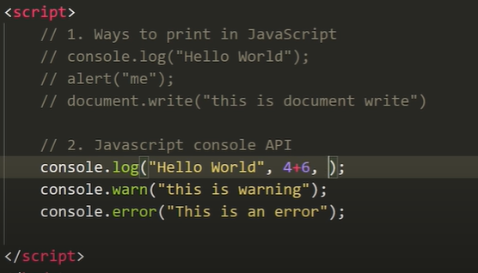

1. Variables in javascript:

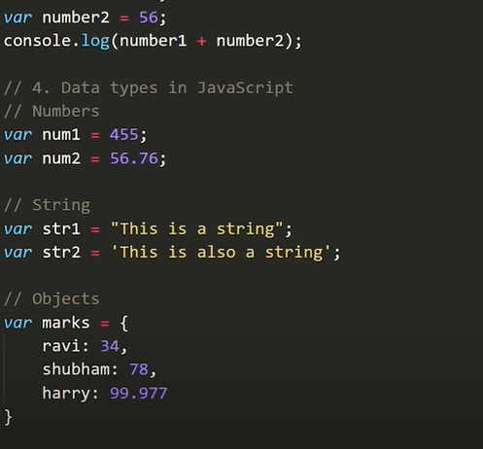

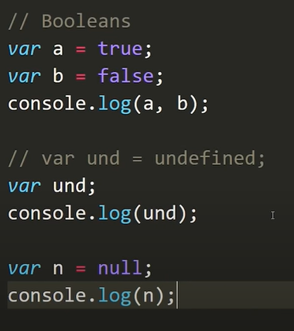

**Undefined** (no value assigned)

**Null** (user don’t want any value their)

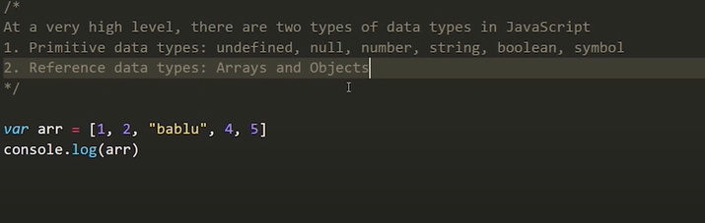

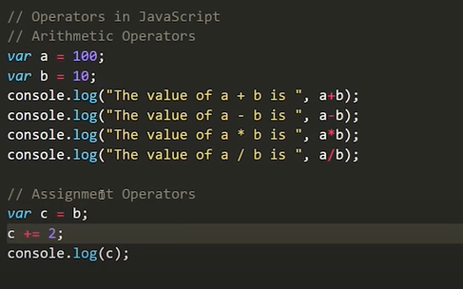

**Functions in JavaScript’s:**

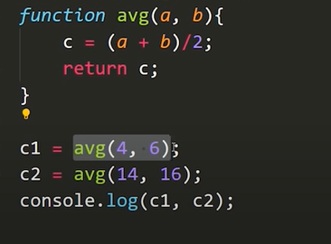

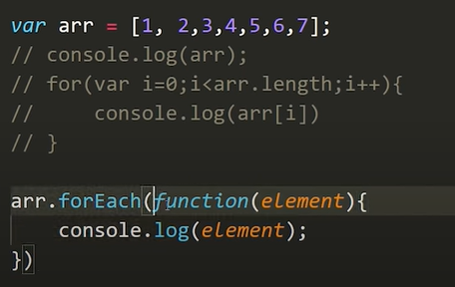

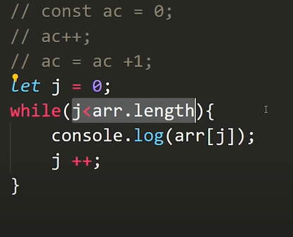

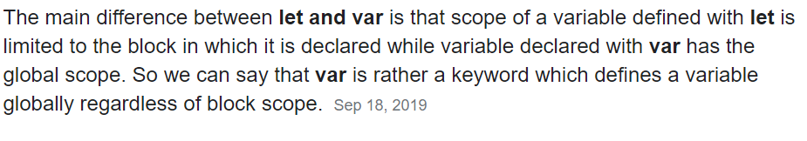

Array Methods:

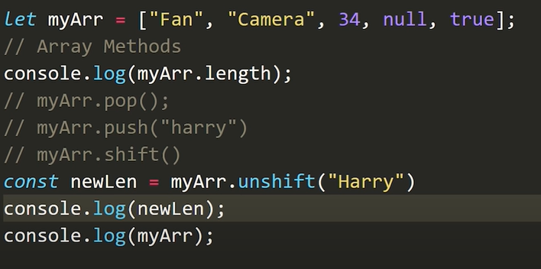

* Myarr.sort();
* Myarr.length;
* Myarr.toString();

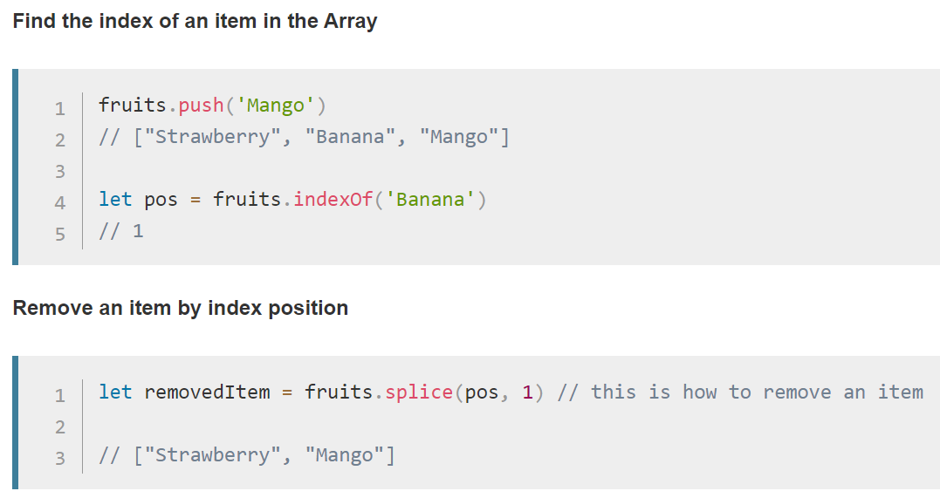

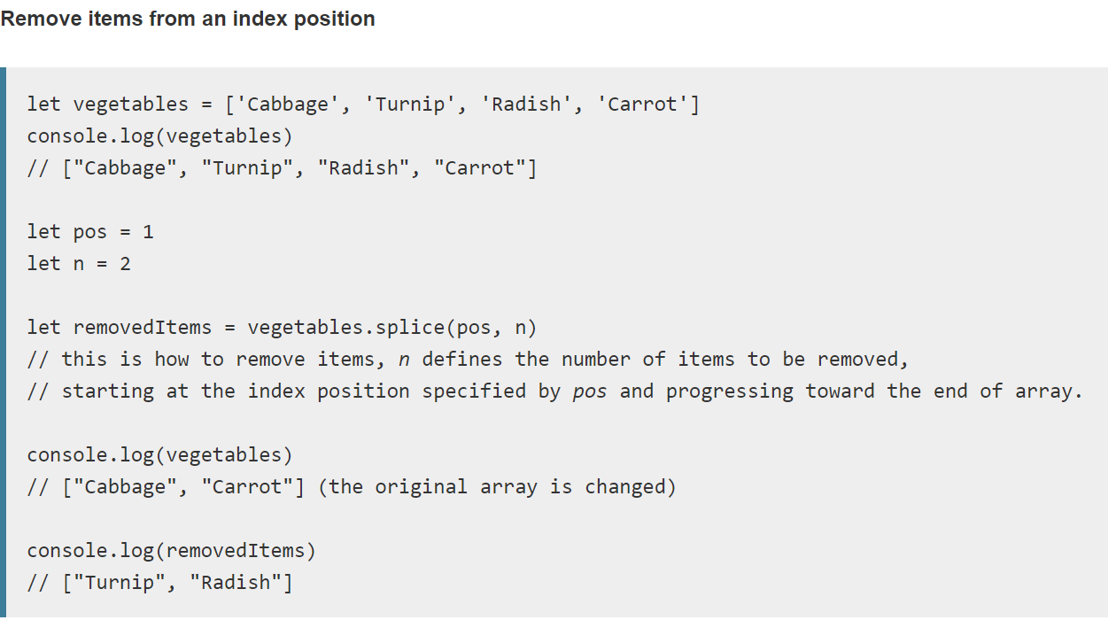

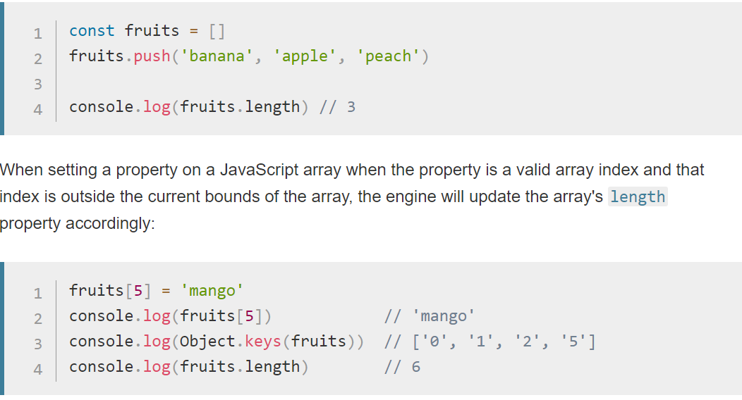

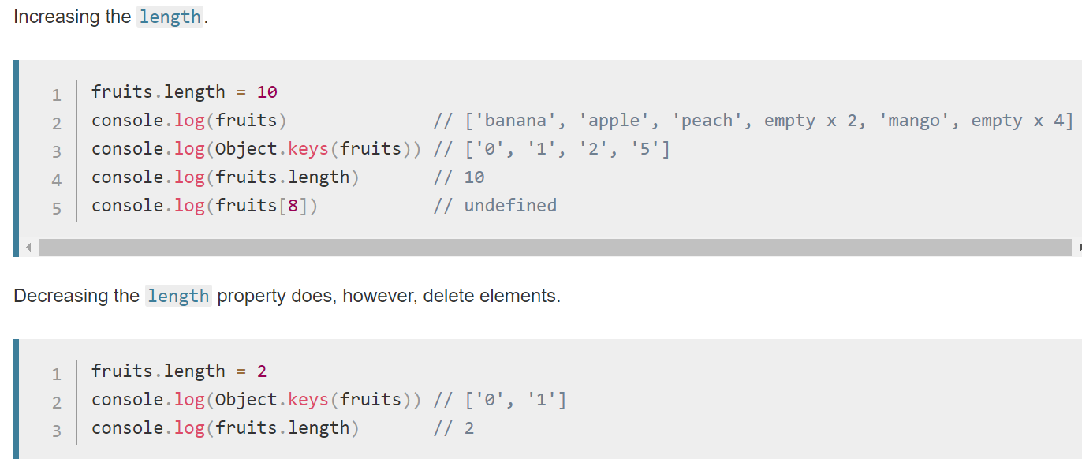

**String Methods in JavaScript:**

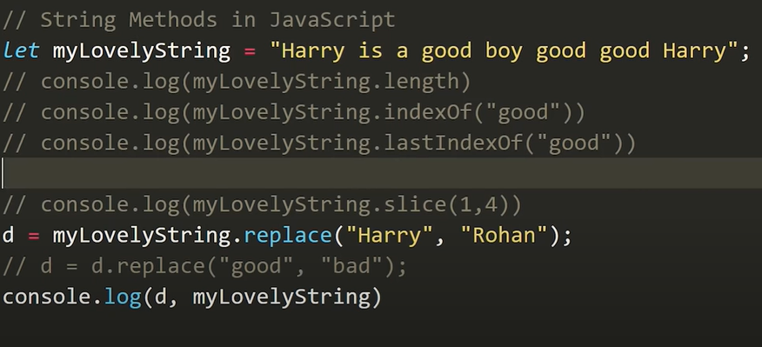

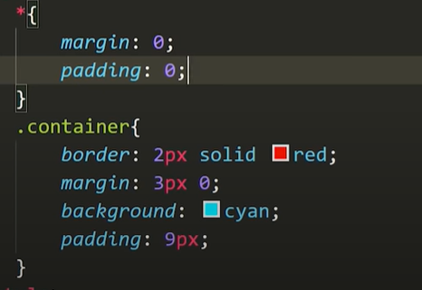

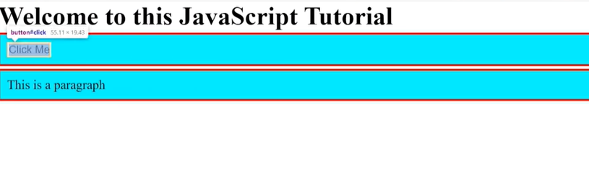

Date:

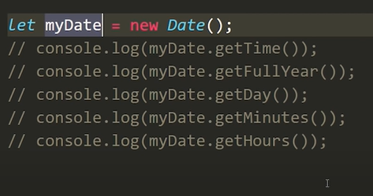

**DOM**

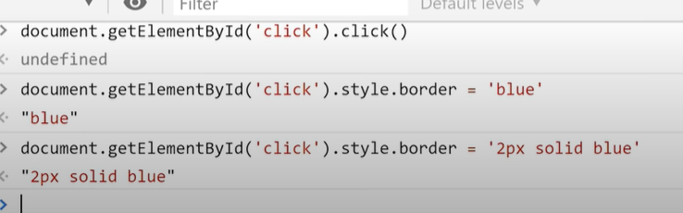

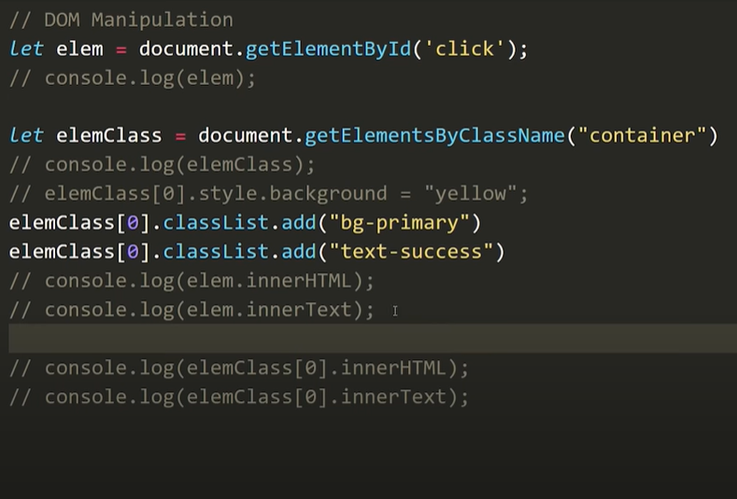

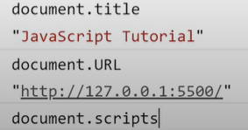

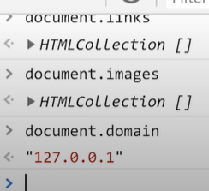

**Select element in the same way css do:**

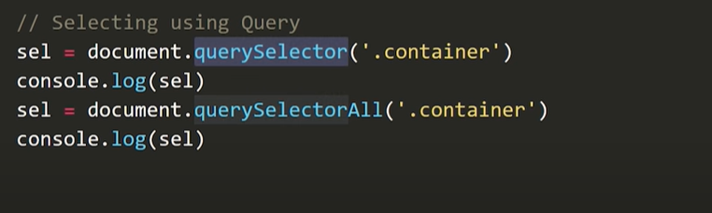

**Events:**



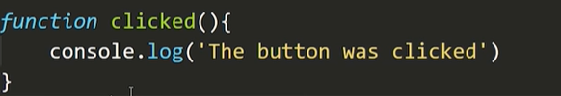

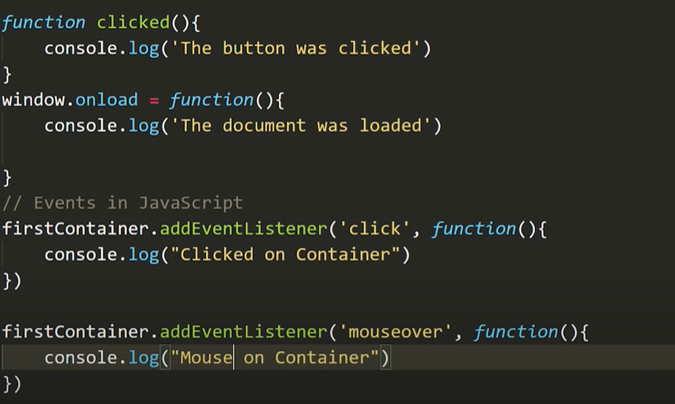

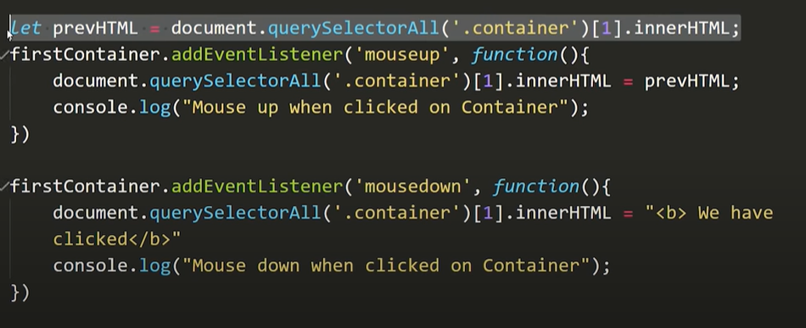

**Set Time out in javascript:**

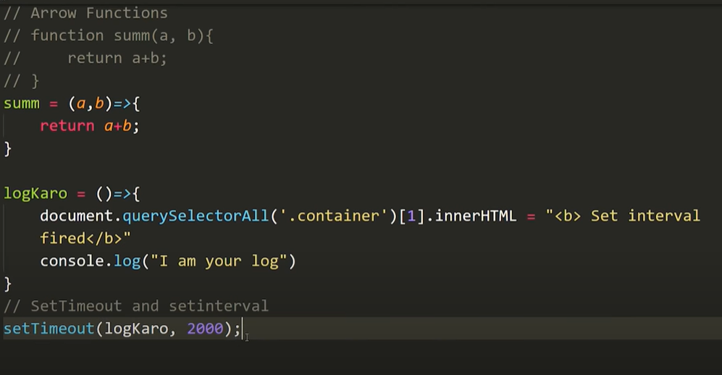

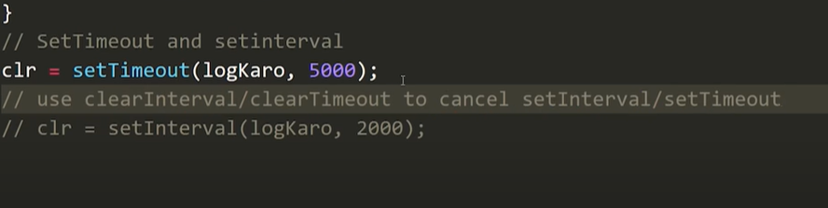

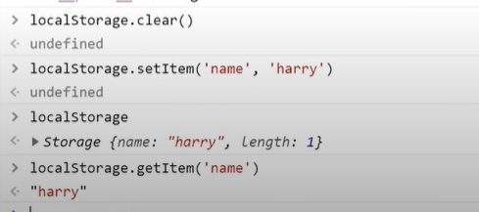

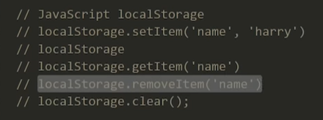

**Json:**

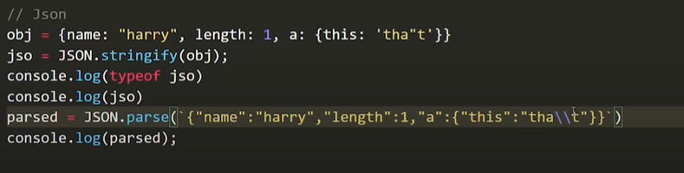

**Project 1: clock**

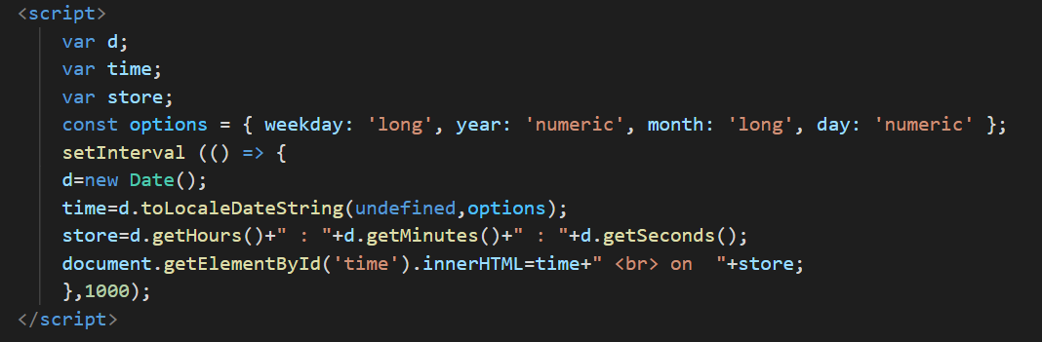

**SetTimeout(function,timeinmilli, para1, para2);**

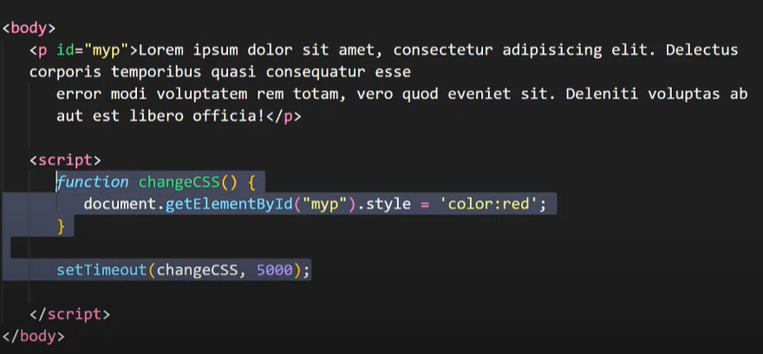

**SetInterval(function, millisec, para1, para2);**

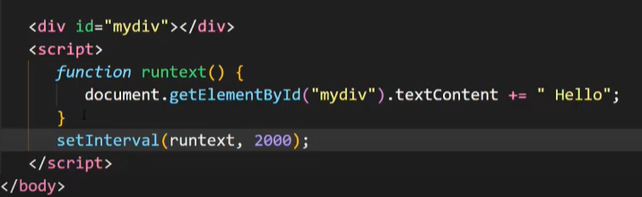

**clearInterval(intervalID);**

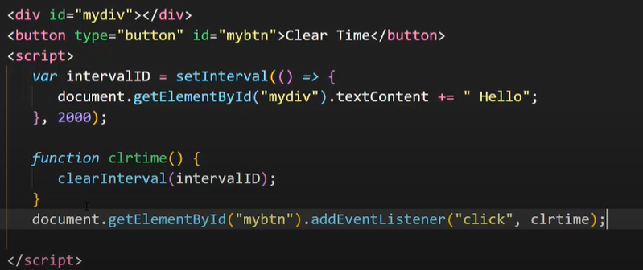

**ClearTimeout(timeoutID);**

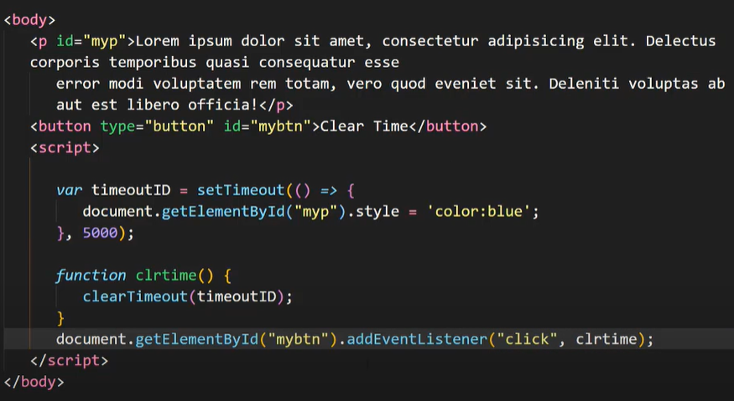

**Project 2:TodoList**

<script>

      function addit(){

        console.log("update.....");

        item=document.getElementById("item").value;

        desc=document.getElementById("desc").value;

           if(localStorage.getItem("itemjson")==null){

             itemjsonArray =[];

             itemjsonArray.push([item,desc]);

             localStorage.setItem("itemjson",JSON.stringify(itemjsonArray));

            }

           else{

            itemjsonStr=localStorage.getItem("itemjson");

             itemjsonArray =JSON.parse([itemjsonStr]);

             itemjsonArray.push([item,desc]);

             localStorage.setItem("itemjson",JSON.stringify(itemjsonArray));

           }

           update();

      }

      function update(){

        if(localStorage.getItem("itemjson")==null){

             itemjsonArray =[];

             localStorage.setItem("itemjson",JSON.stringify(itemjsonArray));

        }

        else{

          itemjsonStr=localStorage.getItem("itemjson");

             itemjsonArray =JSON.parse([itemjsonStr]);

        }

       mytable=document.getElementById("mytable");

       var str="";

       itemjsonArray.forEach((element,index) => {

        str+=` <tr>

        <th scope="row">${index + 1}</th>

        <td>${element[0]}</td>

        <td>${element[1]}</td>

        <td><button type="button" class="btn btn-primary" onclick="deleted(${index})">Delete</button></td>

      </tr> `;

        });

      mytable.innerHTML=str;

     }

      add=document.getElementById("add");

      add.addEventListener("click",addit);

      update();

      function deleted(itemindex){

        console.log("delete",itemindex);

          itemjsonStr=localStorage.getItem("itemjson");

             itemjsonArray =JSON.parse([itemjsonStr]);

             itemjsonArray.splice(itemindex,1);

             localStorage.setItem("itemjson",JSON.stringify(itemjsonArray));

            update();

        }

      function cleared(){

        if(confirm("Do u really want to clear?")){

        localStorage.clear();

        update();

      }

}

    </script>

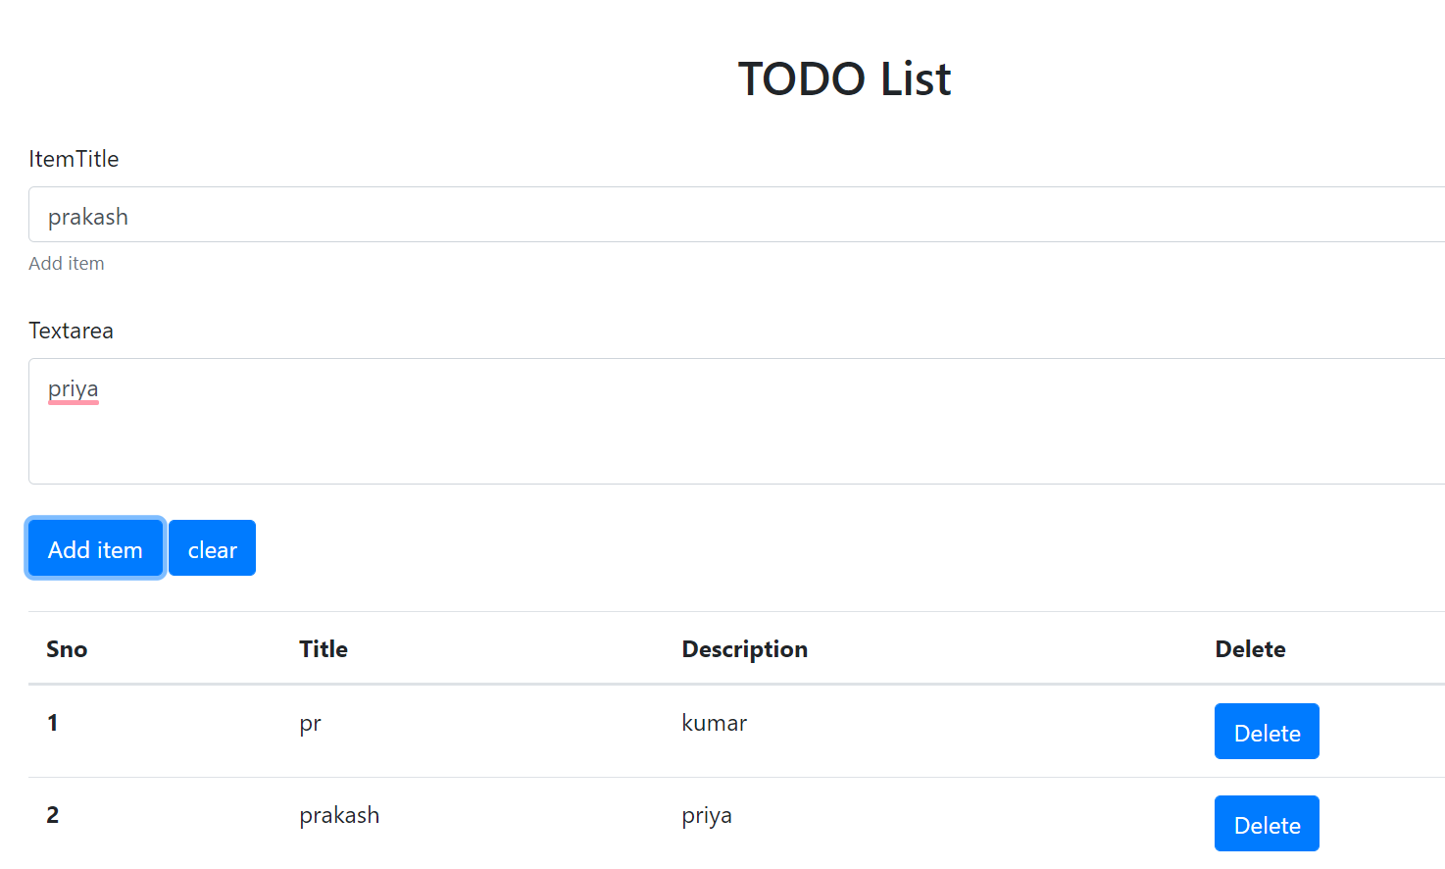

**college calculator**

